American Society of Safety Professionals
Connecticut Valley Chapter
Executive Board Meeting
Friday March 7, 2025

Venue: Zoom

Attendance
Yes No
☐ ☒ Ben Weidman – President-Elect
☒ ☐ Gabriella Gajowiak – President-Elect
☒ ☐ Melissa Noyes – Social Media Chair, incoming Vice President
☒ ☐ Davide Roncari – Incoming Treasurer
☒ ☐ Kevin Galotti – Secretary
☐ ☒ Maryanne Steele – Western MA Section Chair
☐ ☒ Rob Wallace – Western MA Secretary/Treasurer
☐ ☒ Marcia Walsh – Membership Chair
☐ ☒ Liz Velky – Social Media

Quorum: Yes

Call to order: 12:37 PM

Treasurer’s Report

- Total Balance: $36,210.68
  - Revenue: $380.84
  - Expenses: $440.30
    - 390.30 for meeting lunch
    - $50 CT annual business fee
- OSHA Summer Summit Escrow $6,553.46

Old Business:

- Chapter meeting at Kamatics regarding injury prevention and ergonomics.
  - April 15, 2025 12:00 PM – 2:30 PM
  - With tour
  - Lunch provided.
  - Max of 20 people

New Business:

- Motion to by Kevin Galotti to approve $400 for food for the meeting at Kamatics.
  - Second by Gabriella Gajowiak
  - 4 Approved
  - 0 Opposed
  - Motion Passes

- We need to have a meeting for an in-depth discussion dedicated to succession planning. Monday

- Safety 2025
  - Kevin and Davide are going (funded by their companies)
  - Do we want to send anyone else?

Meeting called to a close: 1:02 PM

Meeting Schedule

4/3/2025 12:00 PM
5/1/2025 12:00 PM
6/5/2025 12:00 PM

Respectfully submitted,
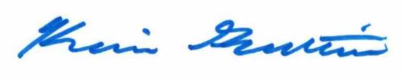
Kevin Galotti – Treasurer

